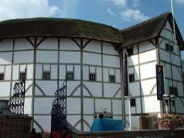
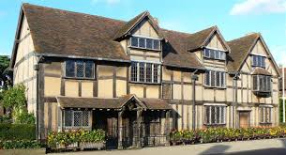
William Shakespeare – a great English poet and writer
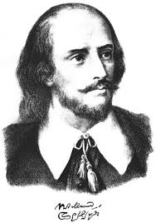
1564-1616

Shakespeare’s birthplace – Henley Street
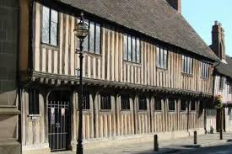
1585. Shakespeare moved to London.
He began to work at “Globe” theatre.
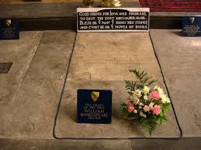

Shakespeare’s wrote:
Shakespeare’s grammar school in 154 sonnets;
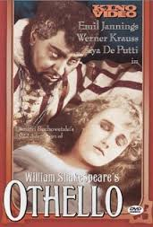
Stratford -upon-Avon 37 plays(tragedies and comedies)
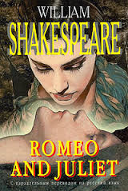
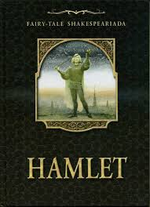
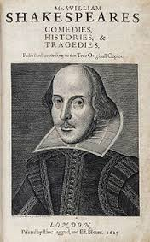
2 poems 1616 – Shakespeare died

