***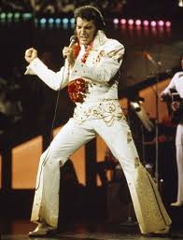****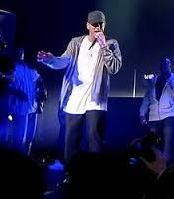****Music styles and famous singers***

**Rock and Roll The Blues**

**British Beat Heavy Metal**

**Reggae Rap**

**Jazz**

**Marshall Bruce Mathers III (born October 17, 1972),**

 **better known by his stage name Eminem is an American**

**Elvis Aaron Presley (January8, 1935- August 16, 1977) rapper, record producer, songwriter and actor.**

**was an American singer and actor. He is often referred**

**to as “the King of Rock and Roll”, or simply, “ King”.** 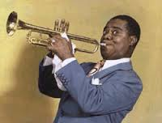

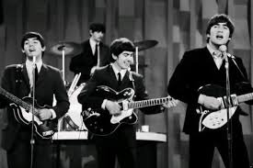

**Don’t worry, be happy**

**with a nice music**

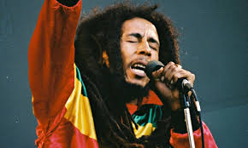

**Louis Armstrong (August 4, 1901-July 6, 1971),**

**Nicknamed Satchmo or Pops, was an American**

**jazz trumpeter, composer and singer who became**

**The Beatles were an English rock band, formed in one of the pivotal and most influential figures in Liverpool in 1960. With members John Lennon, jazz music.**

**Paul McCartney, George Harrison and Ringo Starr,**

**they became widely regarded as the foremost and**

**most influential act of the rock era. Robert Nesta “Bob” Marley (February 6, 1945 – May 11, 1981),**

**was a Jamaican reggae singer, songwriter, musician and guitarist.**